LAB BOOK 2

JAY VASANI

INFO 2260

KHURAM KHALID

22 JULY, 2023

LAB 2.1

PART A

Create 3 new users as part of the IT department.

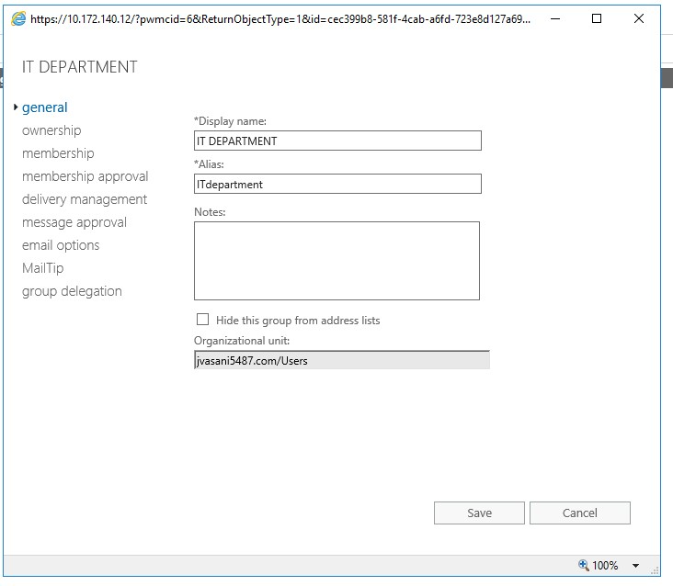

Create 3 new users as part of the IT department.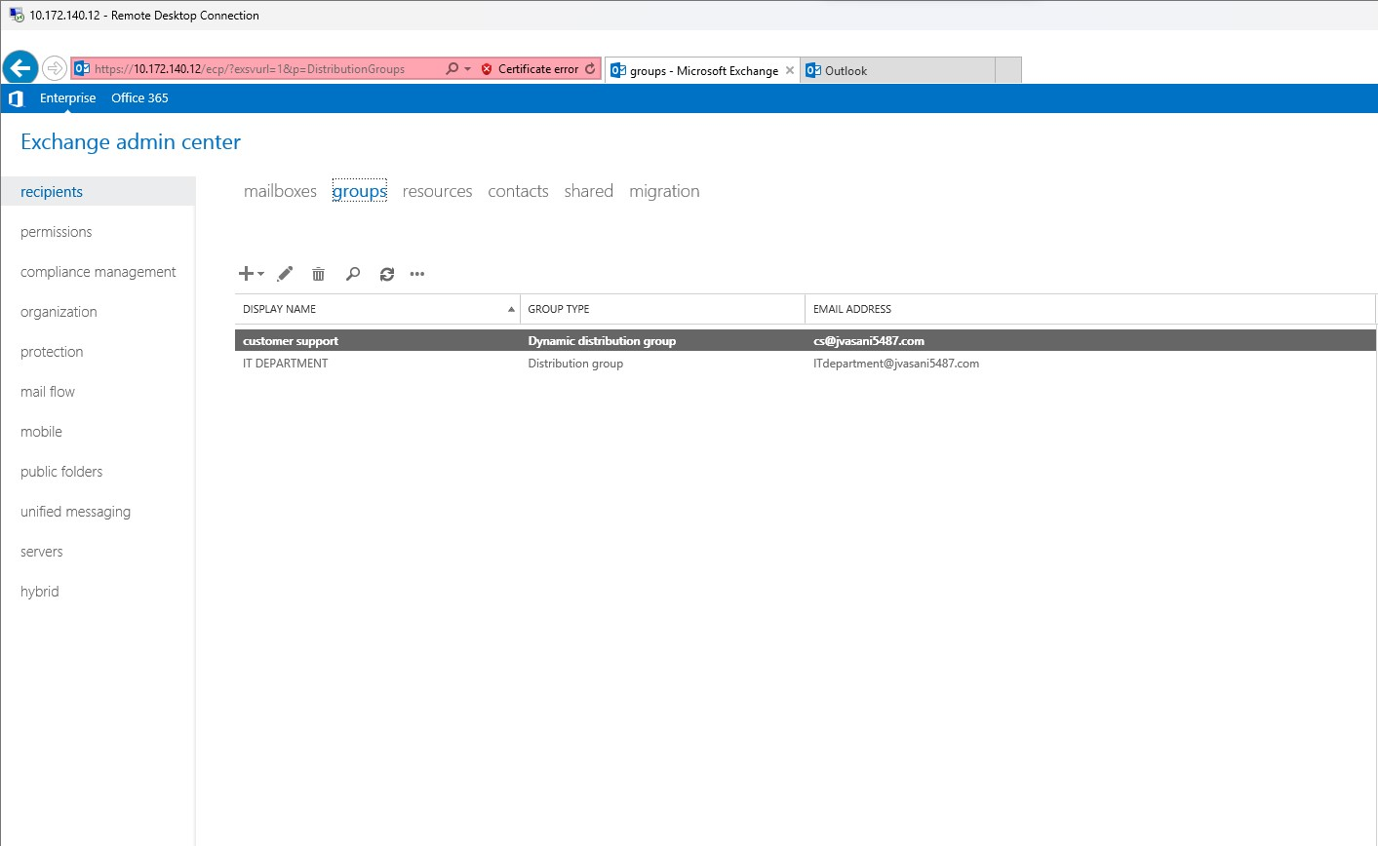

show that you can send email  
to this Group and that the members receive it

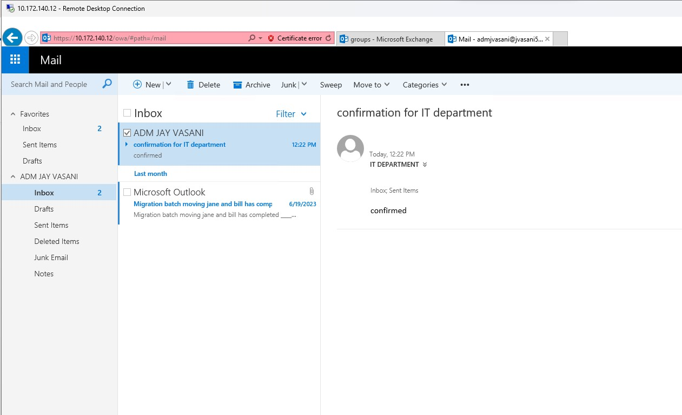

PART = B

Create a Dynamic Distribution Group for the department you have created.

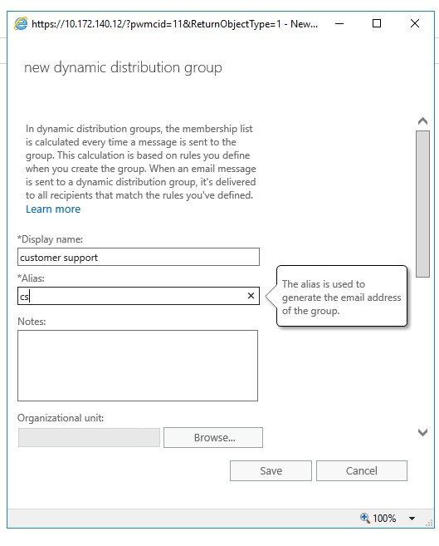

Create a Dynamic Distribution Group for the department you have created.



This screen shot shows that i can send email  
to the group and that the members receive it.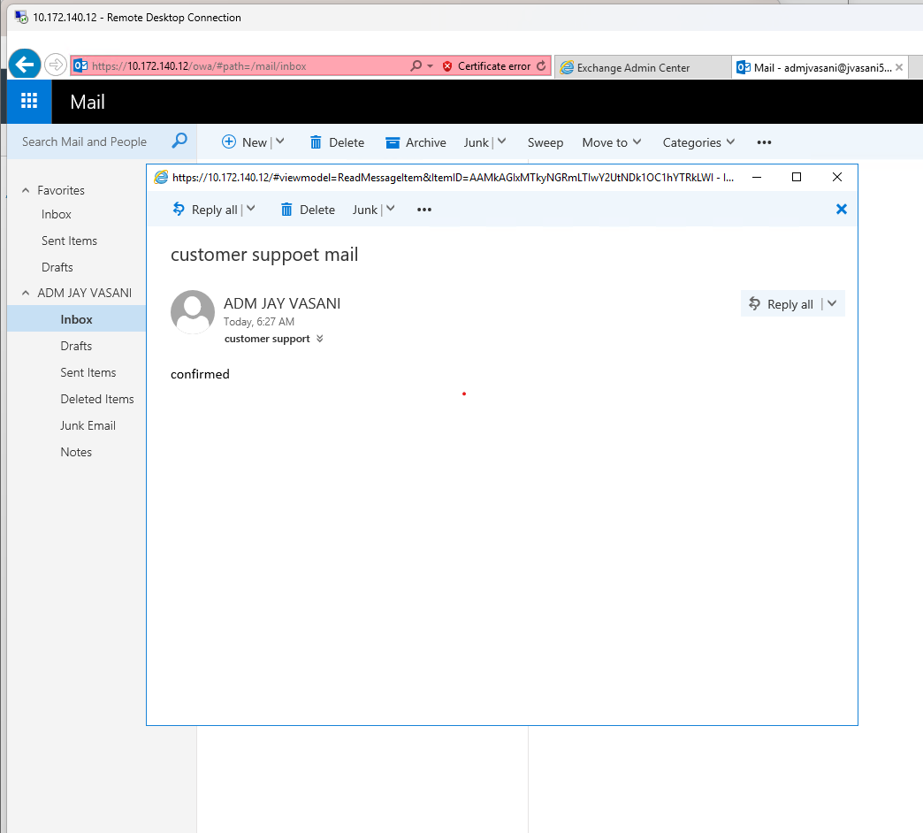

Part c

Show that at least one of the members of the IT department can access the mailbox and reply to the email sent from Jane.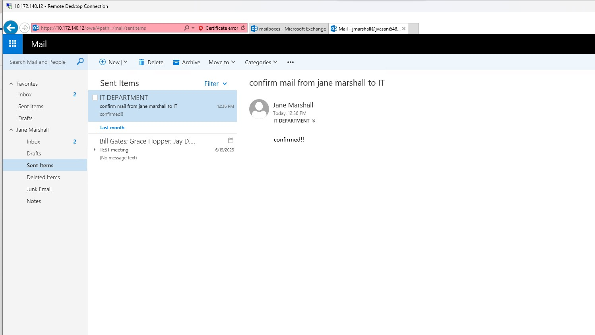

LAB 2.2.

PART A

Create a rule that sets any email received from Bill Gates as the red category.

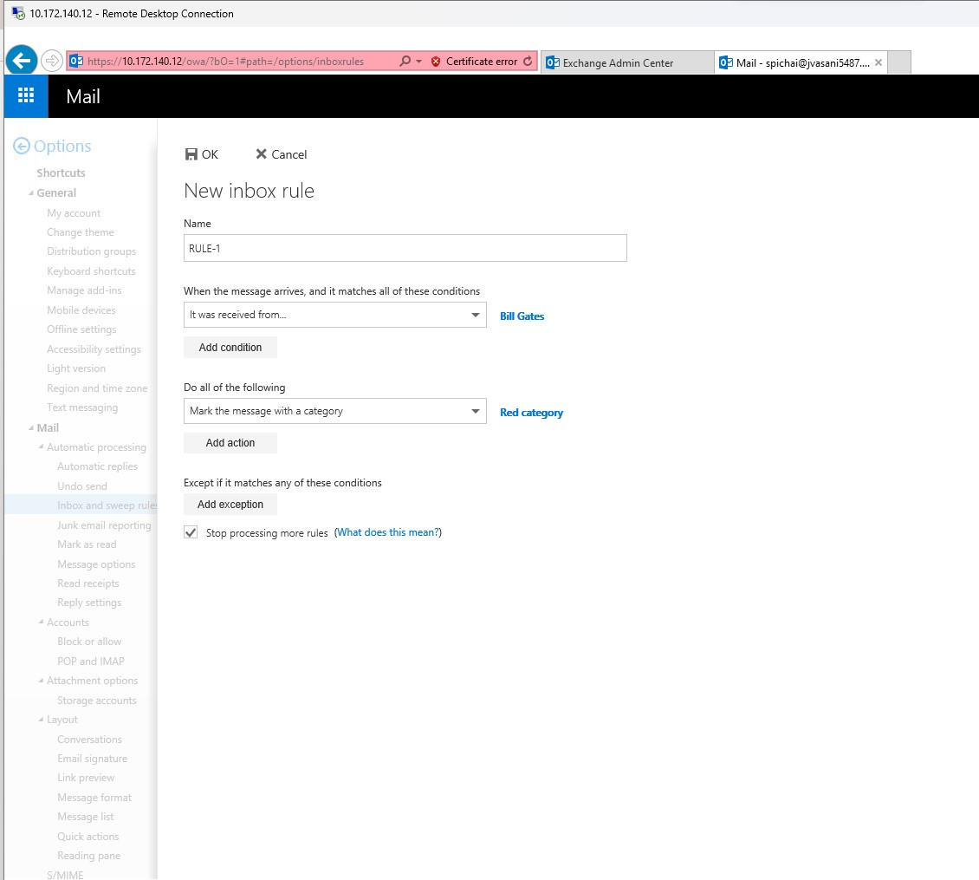

Create a rule that sets any email sent to the IT department as the blue category

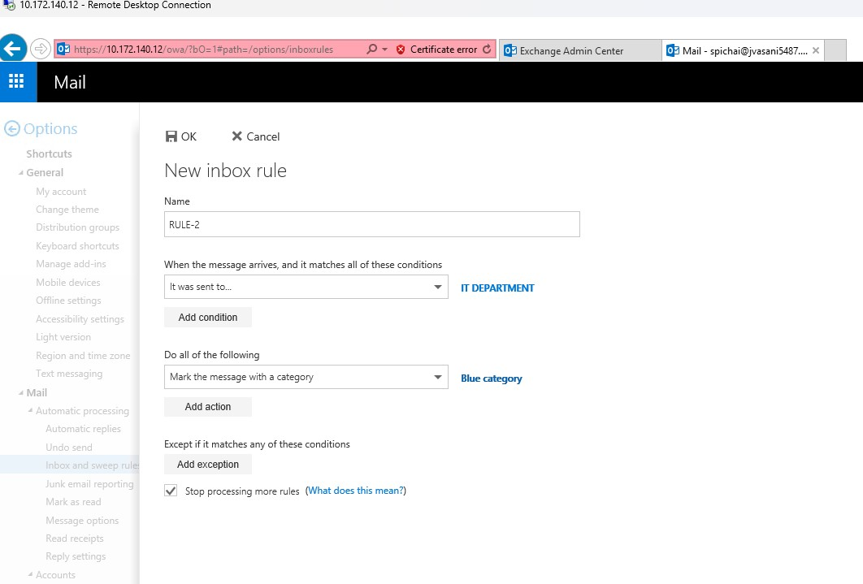

Create a rule that redirects any email from Grace Hopper to Alan Turing.

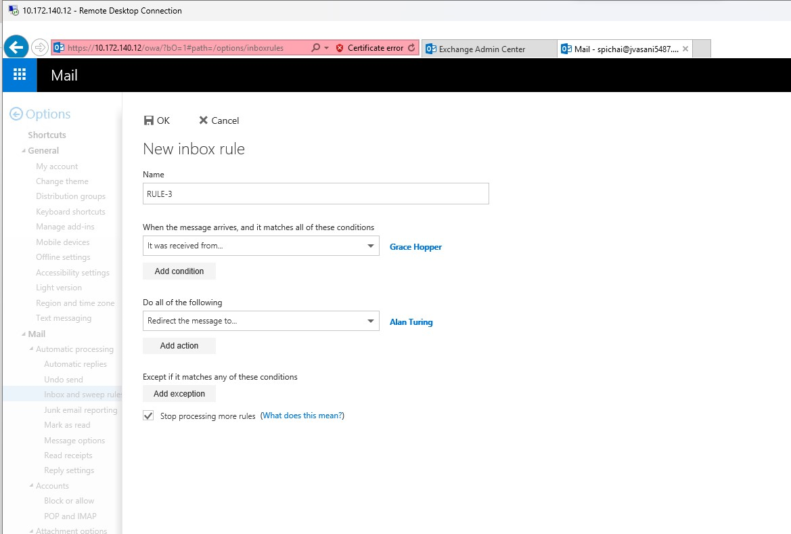

Output of red catagory

0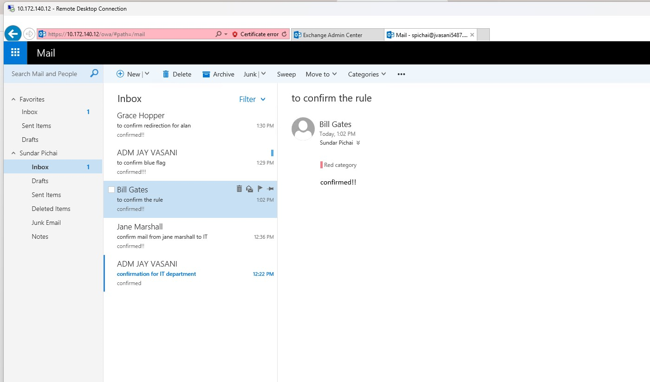

Output of blue catagory

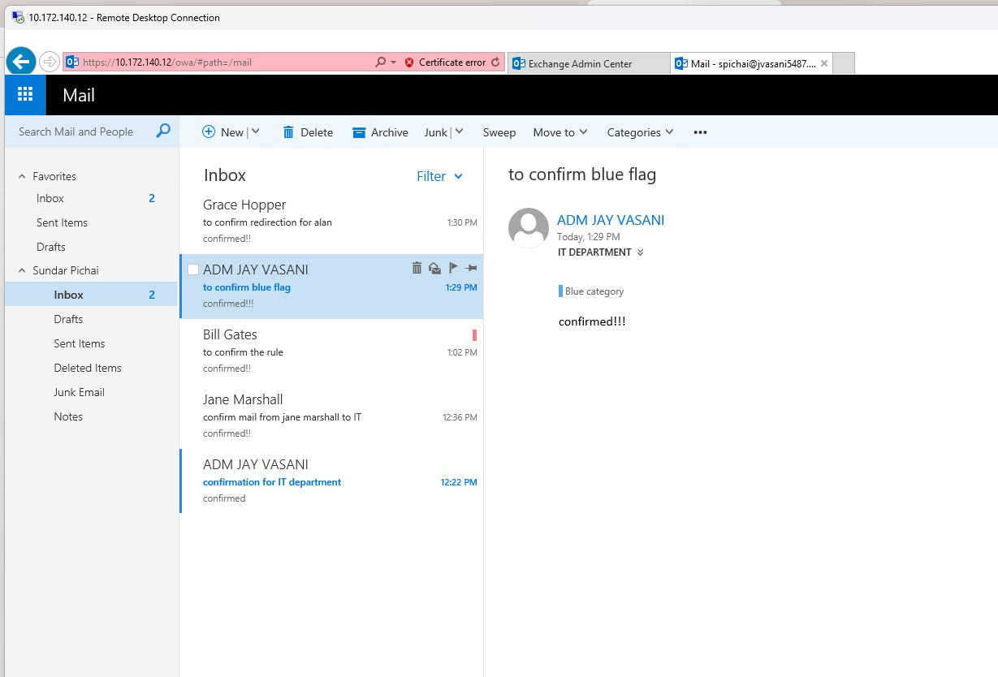

Output of redirection to alan turing

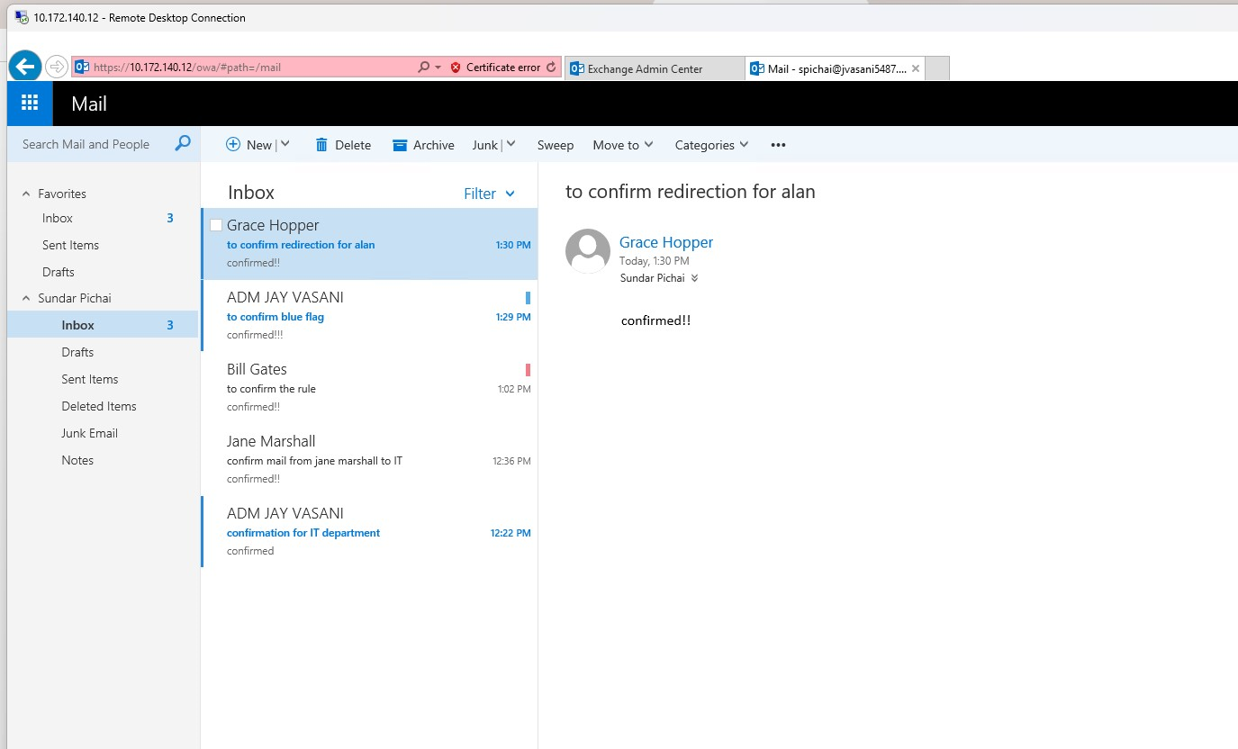

PART B

Create an Out of Office message for Sundar Pichai. Send an email to Sundar and show the Out of Office reply that is received

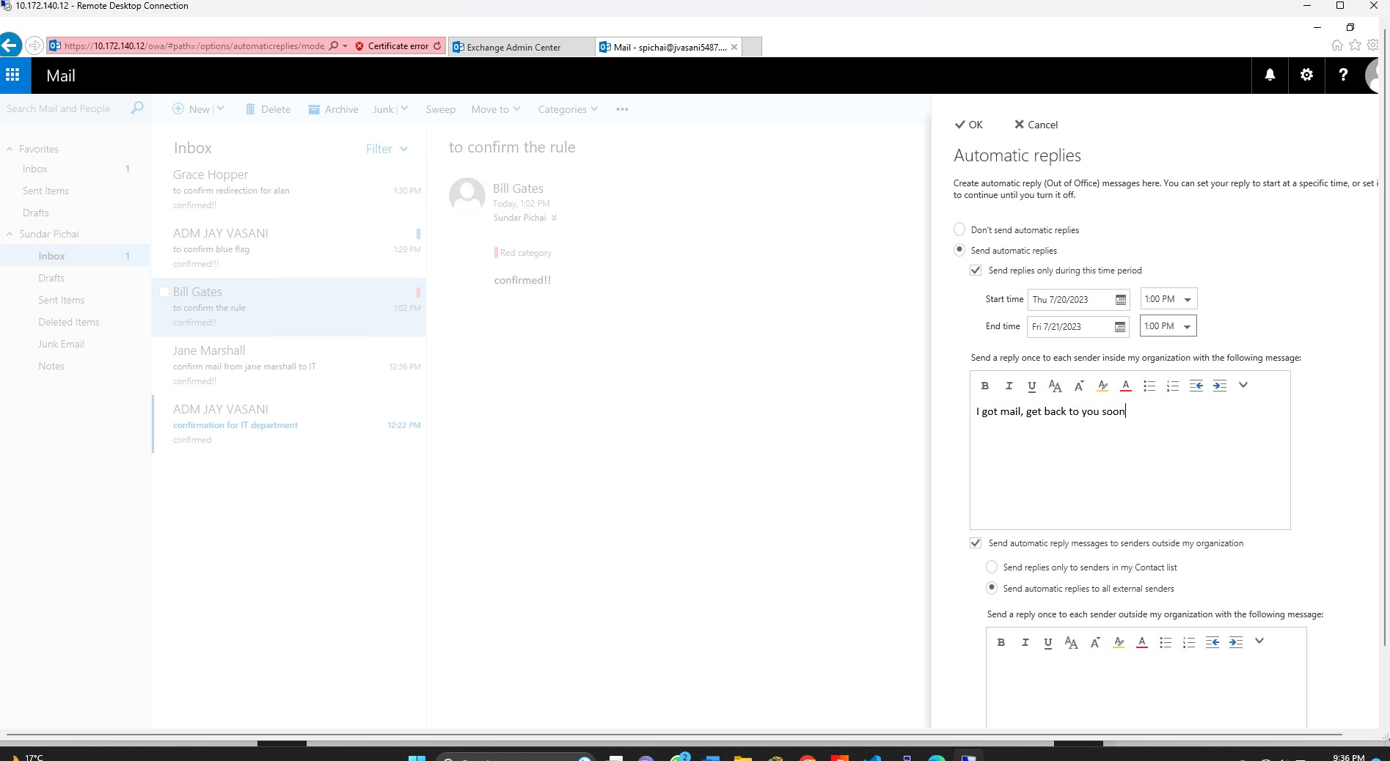

Output of auto reply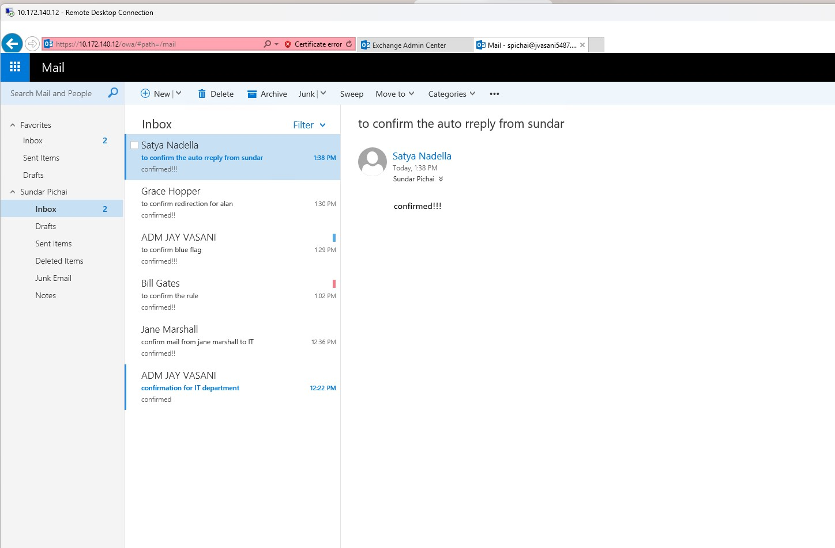

Create an Out of Office message for Satya Nadella.  
Set a different message for internal senders than for external senders.

Set it so that the Out of Office message will only apply from November 1st to November 5th,  
2020

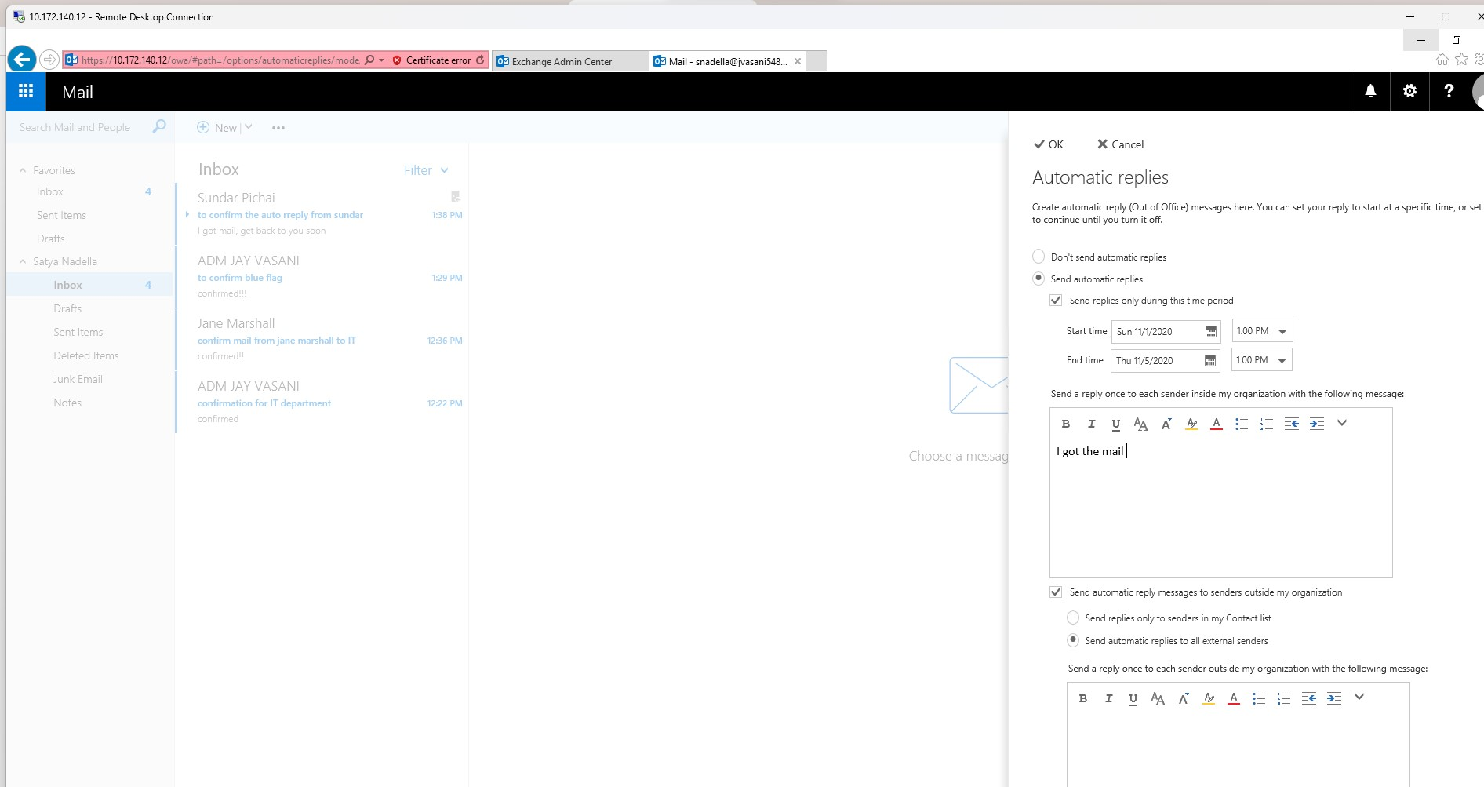

Part c

Create a mail rule to not allow Steve Rogers to send any messages to Jane Marshall with a  
message going back to Steve saying it is not allowed

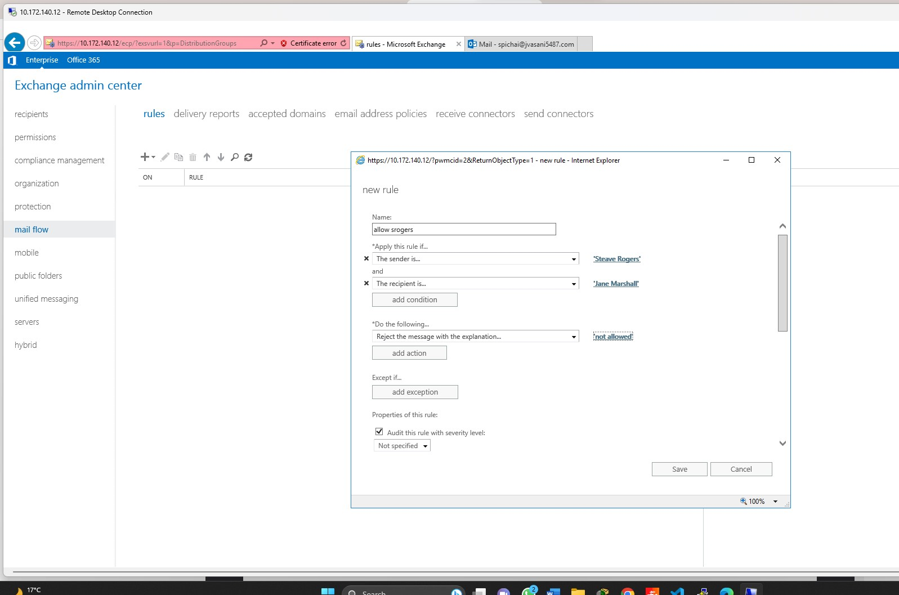

Output mail that shows it is not allowed

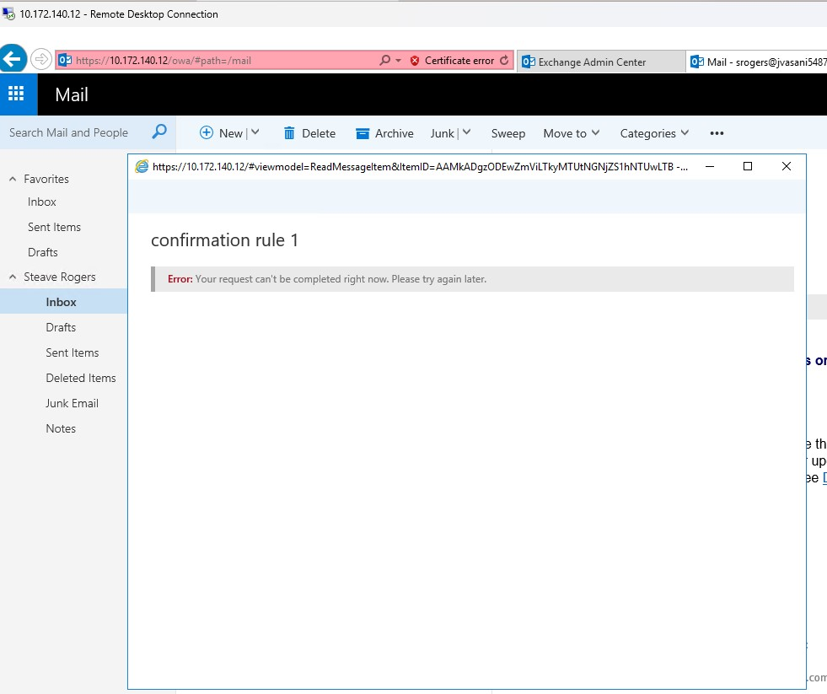

Create a mail rule to prepend the subject of any message with “From the Chairman” that  
Bill Gates sends out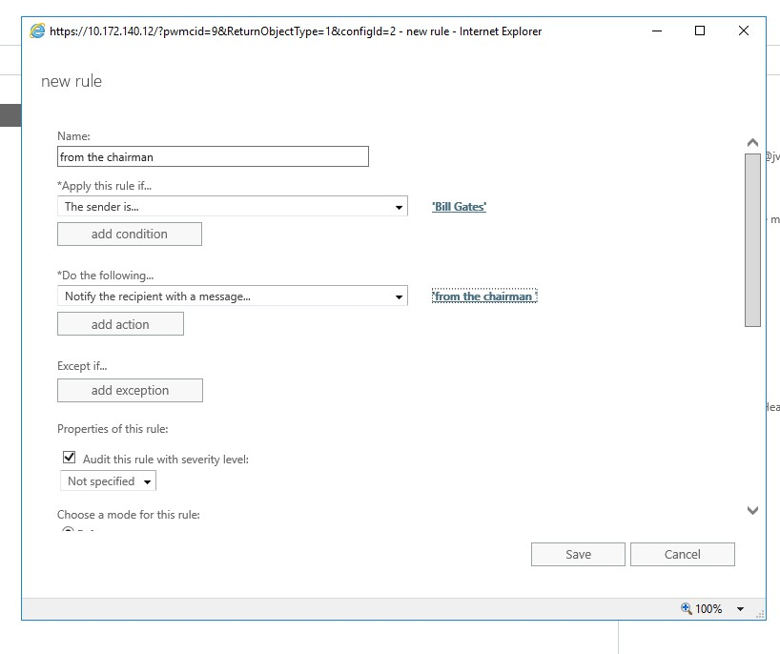

Output showing that it is from the chairman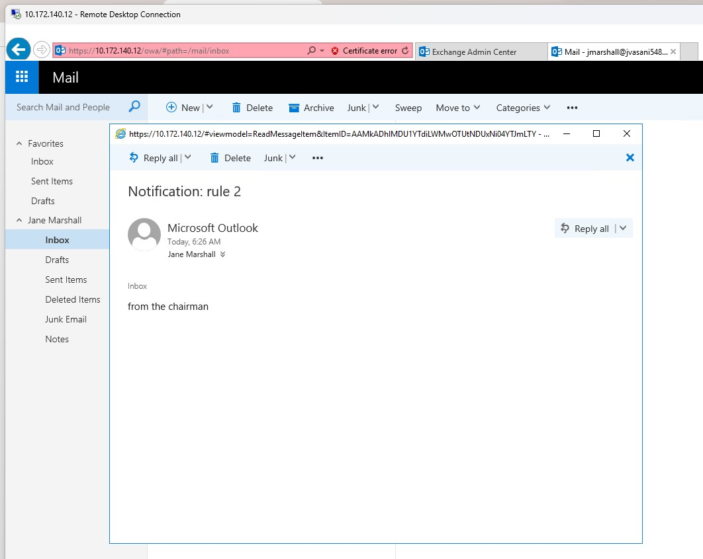

For any message that Bruce Banner sends out add Steve Ballmer to BCC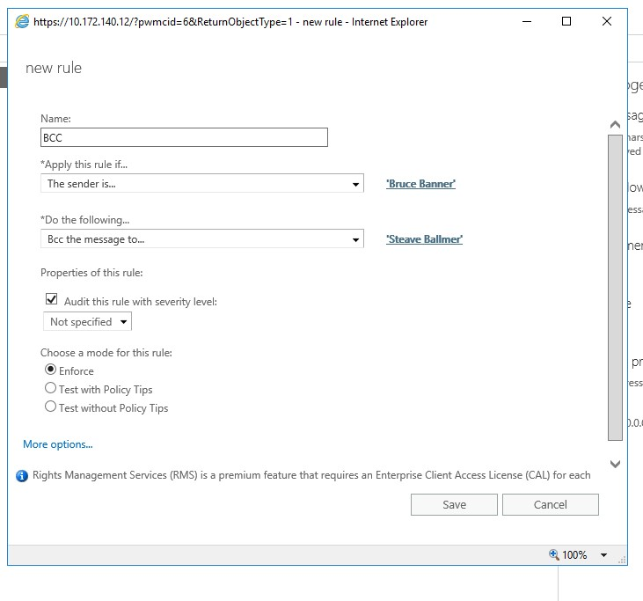

Output that shows that bcc rule is confirmed and steave is in bcc 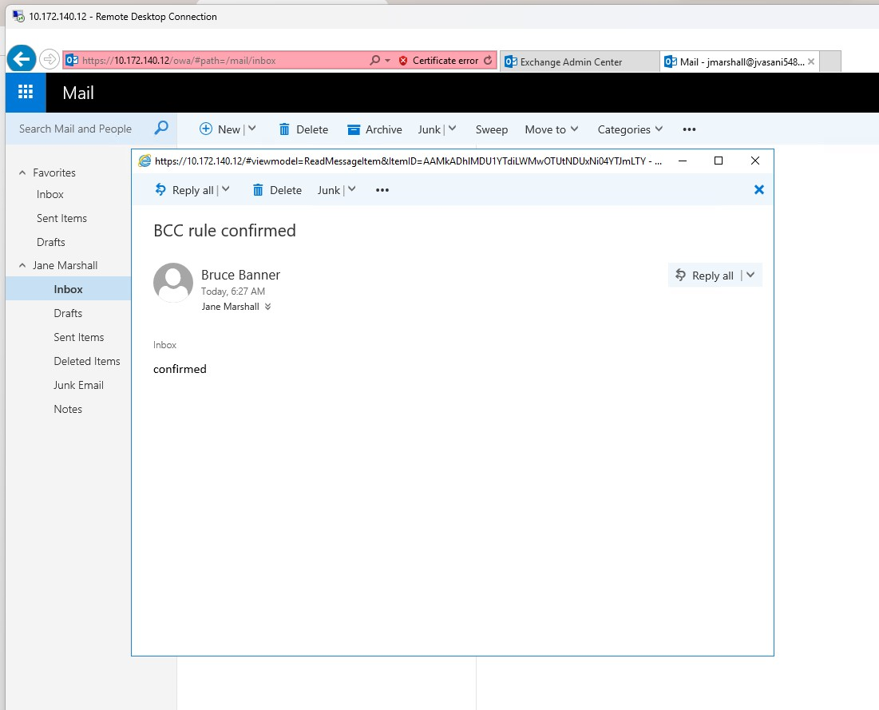

Put a disclaimer on all messages sent by Tony Stark. You choose what it should say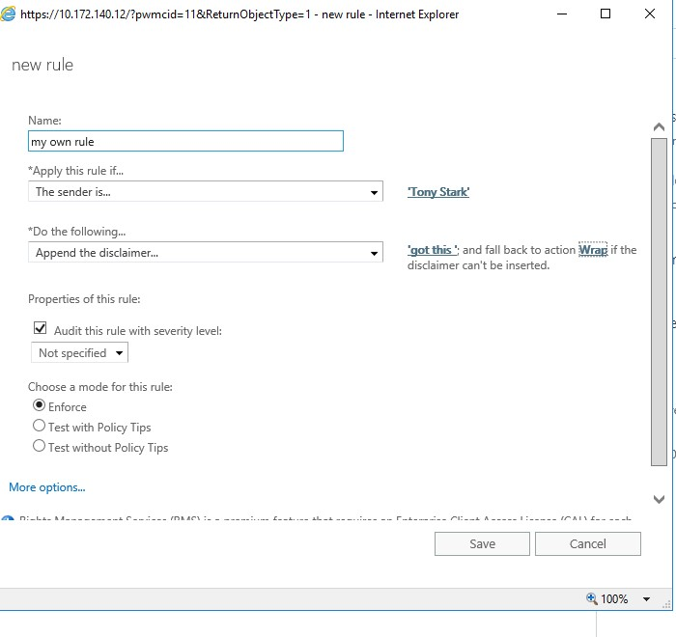

Out put of my rule 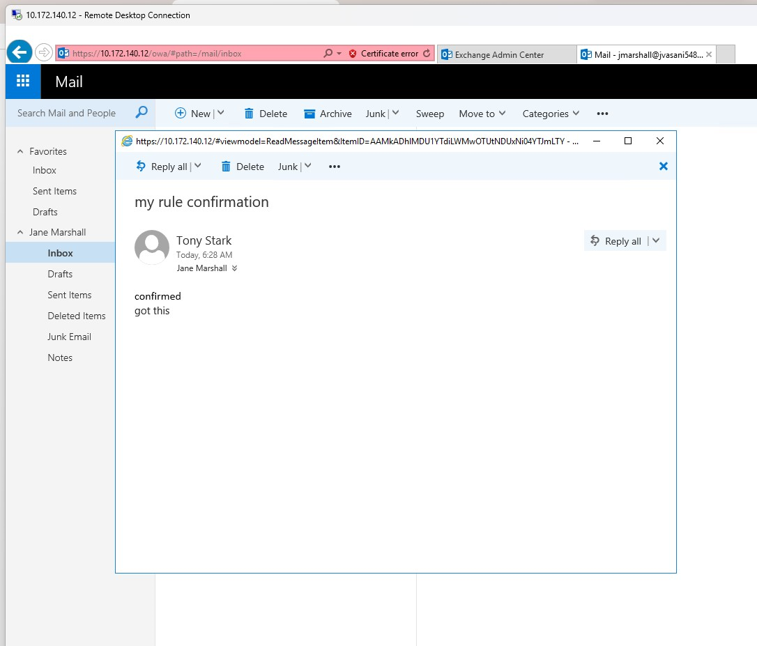

Forward any email sent by Alan Turing to the Steve Rogers be approved by Bill Gates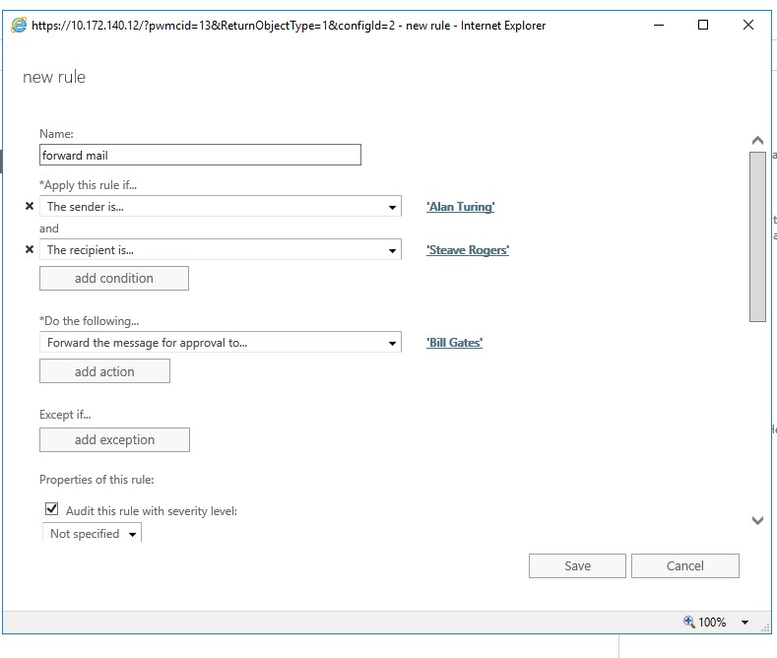

Asking permission to bill gates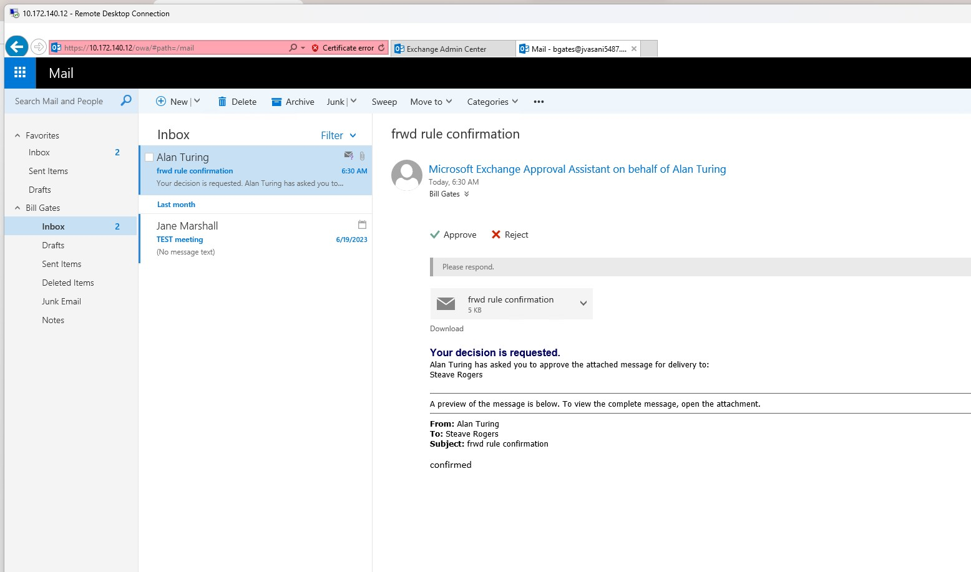

After giving permission mail recieved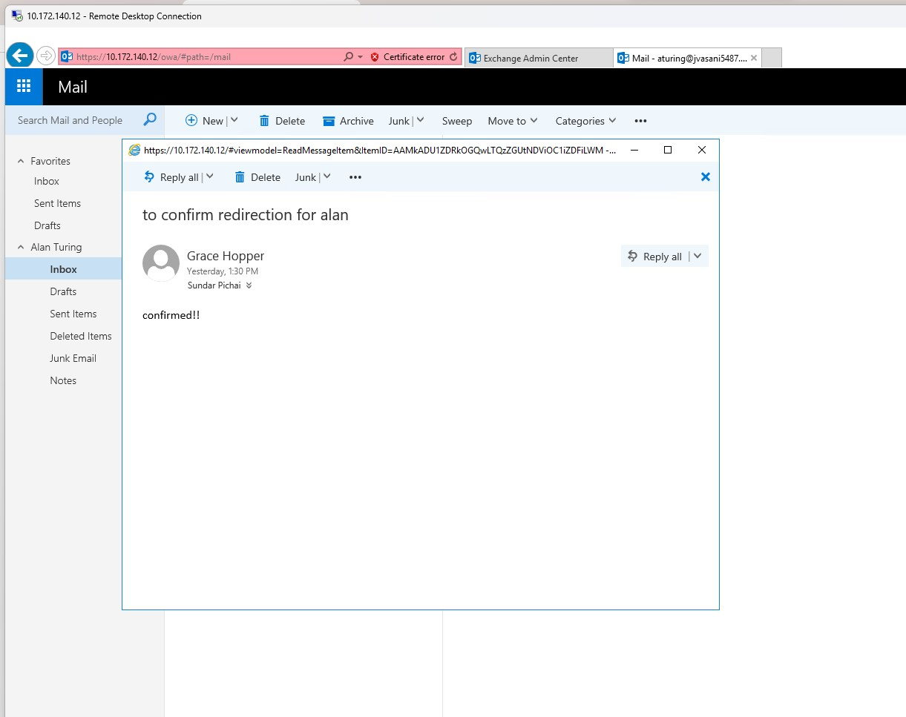

LAB 2.3

PART A

List all mailboxes in your organization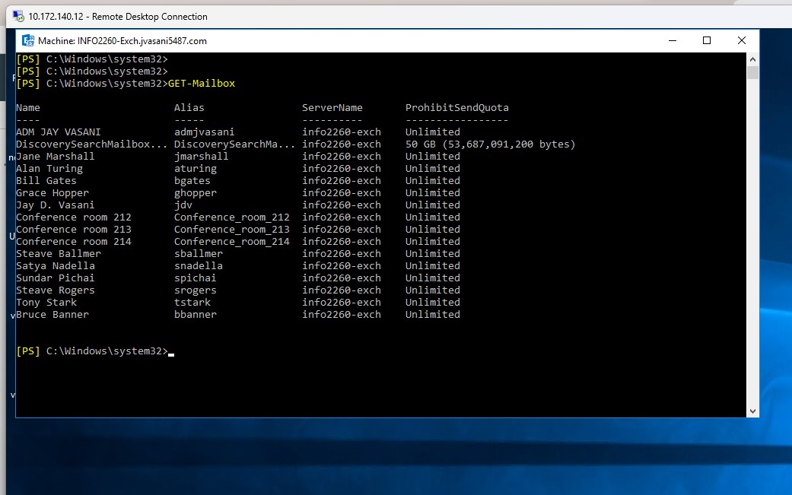

List all of the mailbox attributes for Grace Hopper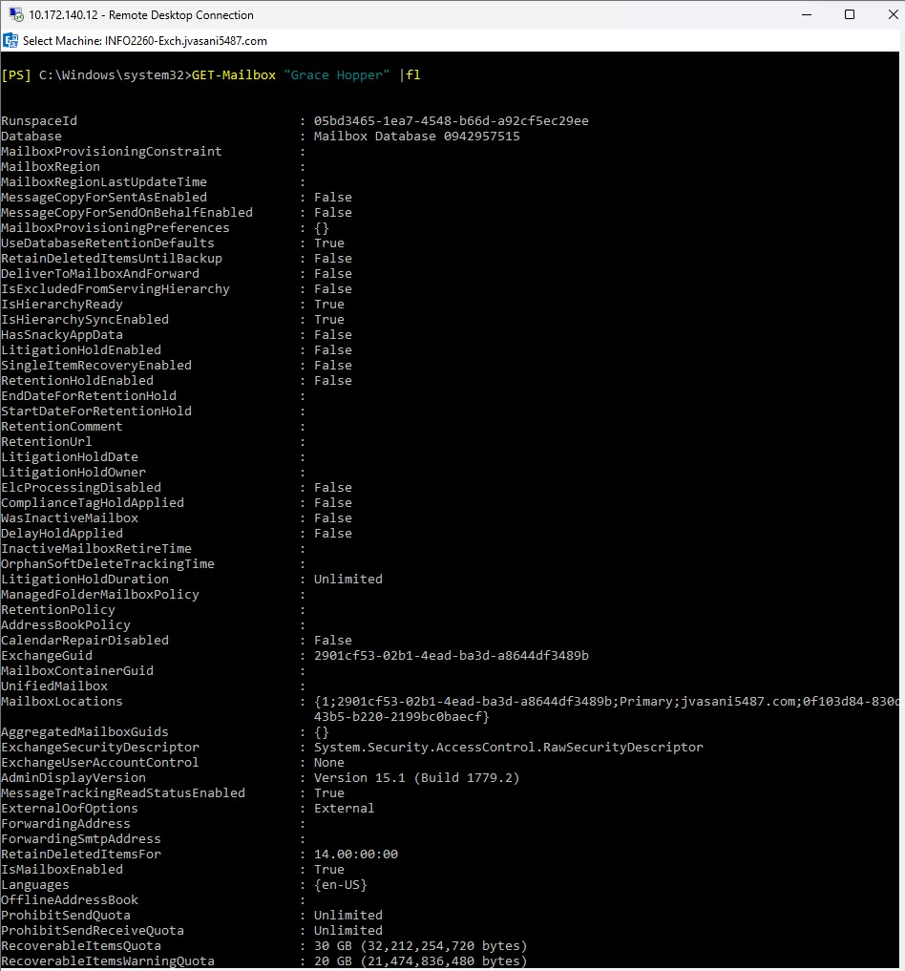

List the permissions applied to Bill Gates mailbox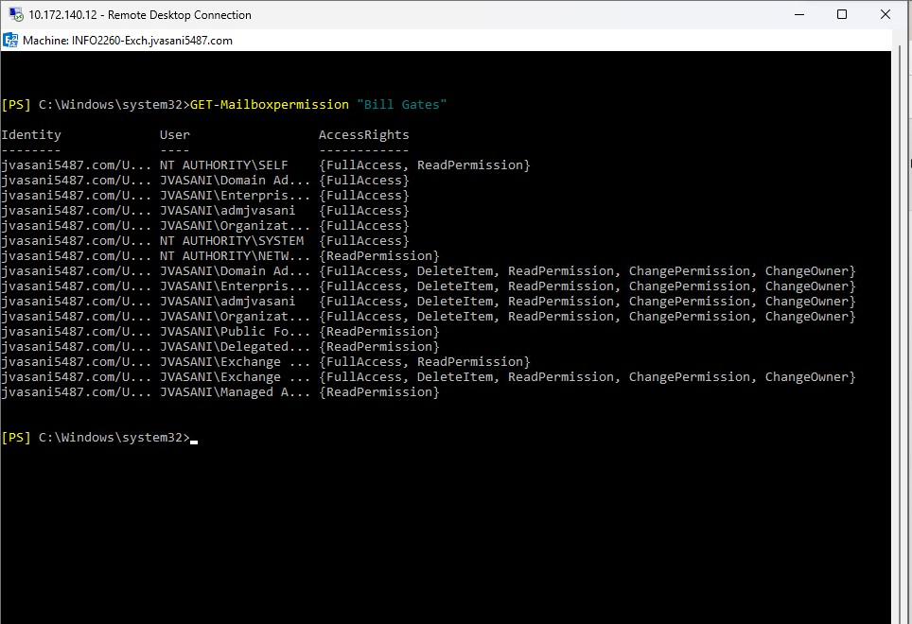

List the Name, alias, Primary Email Address, Organizational Unit, Mailbox Type for all users in your organization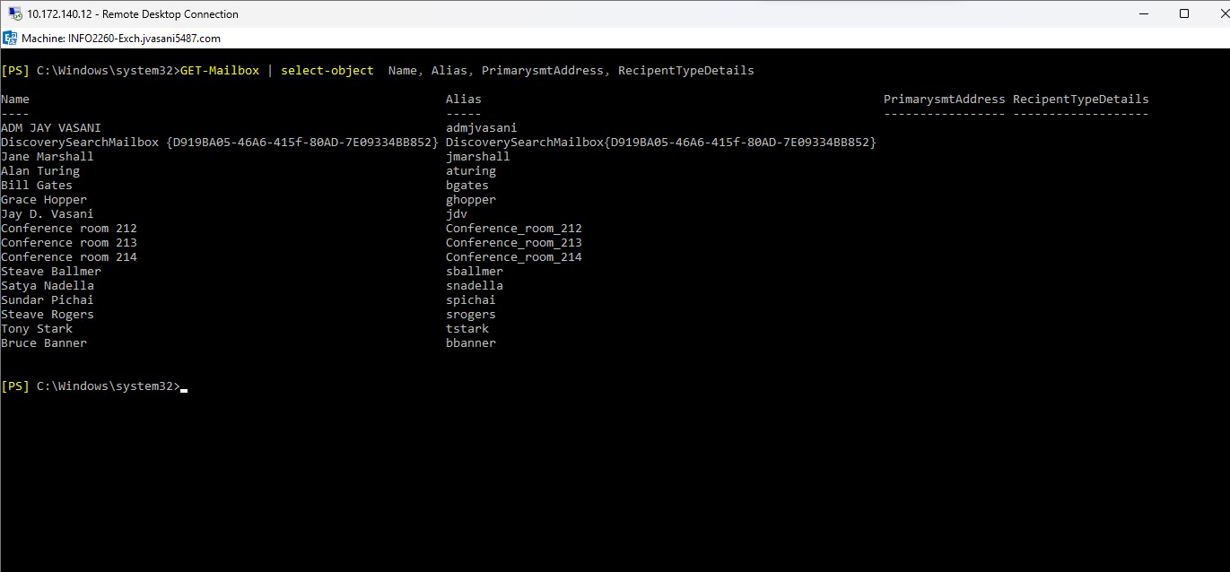

List the Name, alias, Primary Email Address, Organizational Unit, Mailbox Type for all users in your organization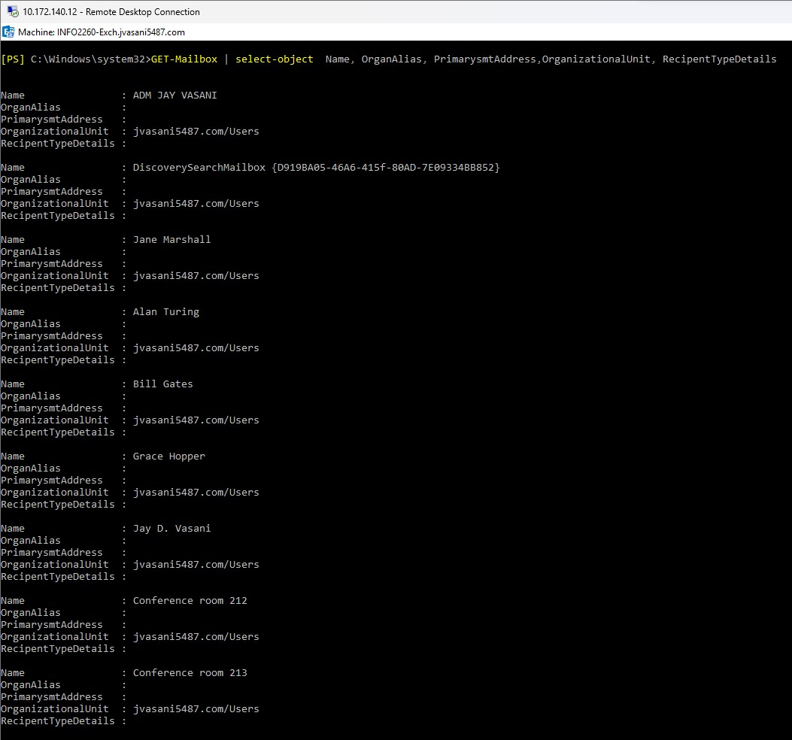

List all the mailboxes in the mailbox database you created during lab book #1.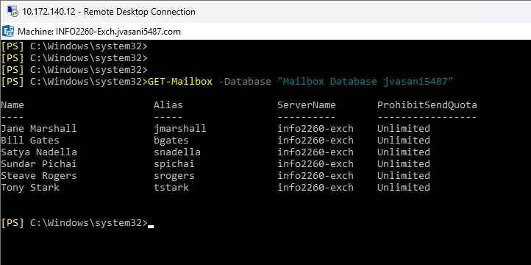

List the mailbox statistics for Jane Marshall, Show only the ItemCount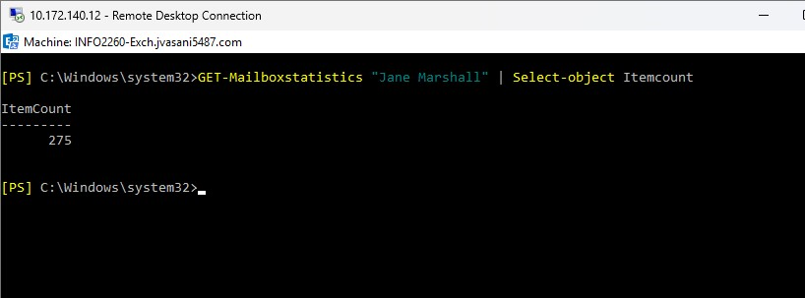

Export all mailboxes to a CSV file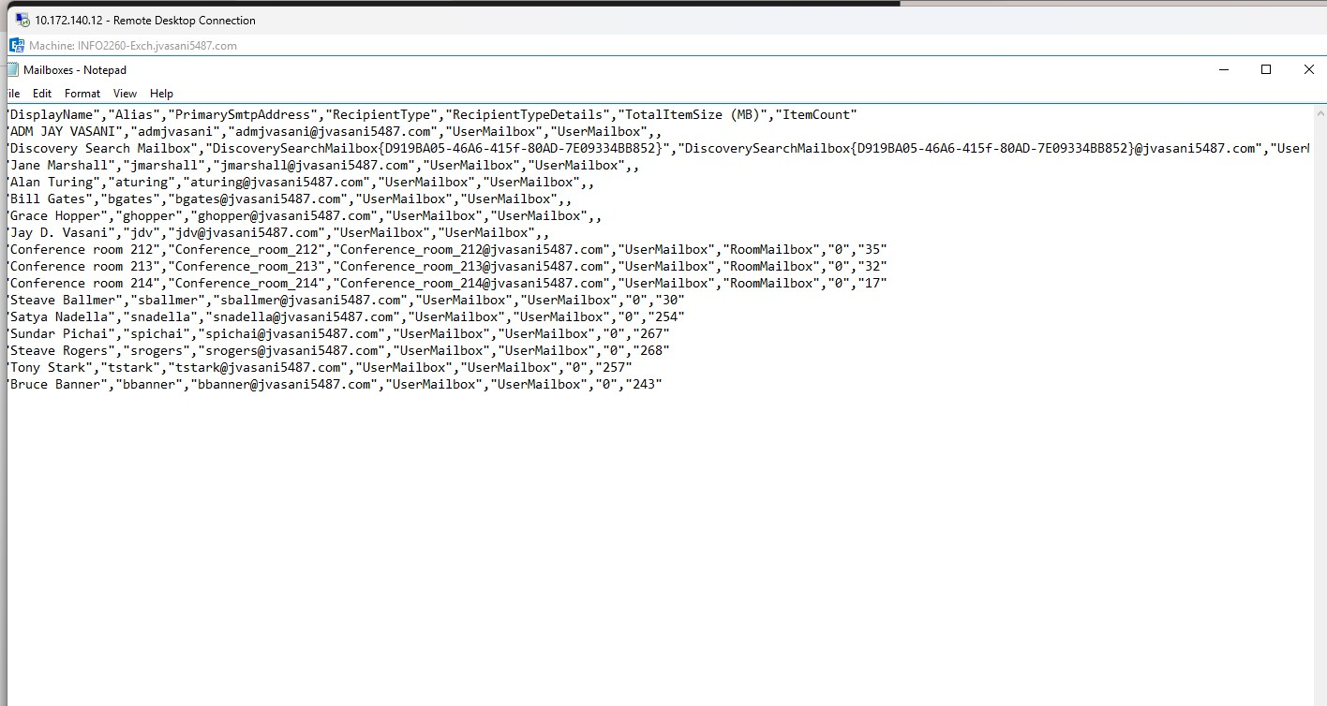

LAB 2.4

PART A

Create 2 new users  
a. Kevin Hart  
b. Josh Gad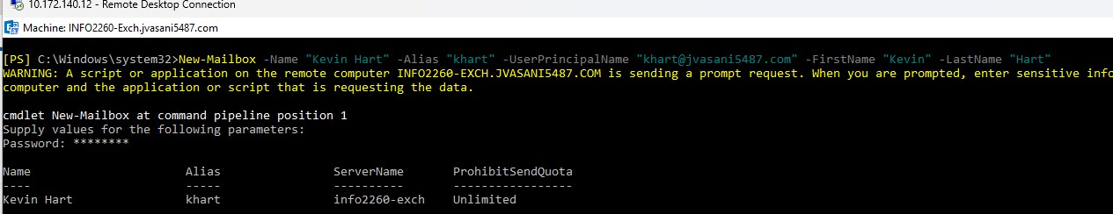

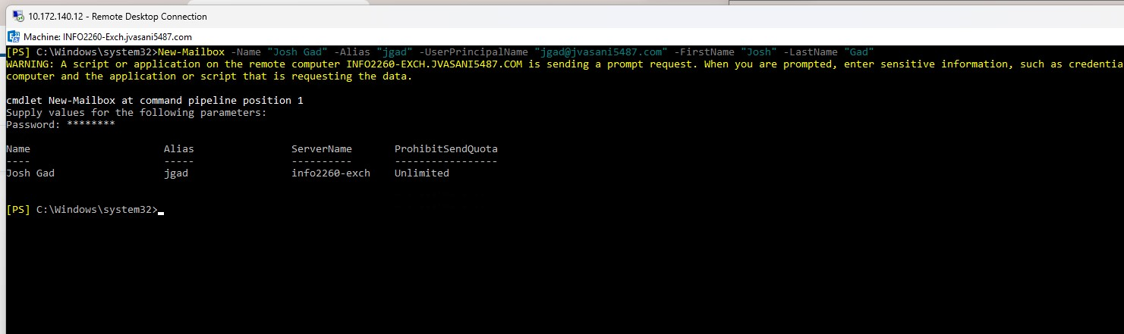

Set the following Department and Job Titles:  
a. Kevin Hart  
i. Title: Comedian  
ii. Department: Marketing  
b. Josh Gad  
i. Title: Actor  
ii. Department: Marketing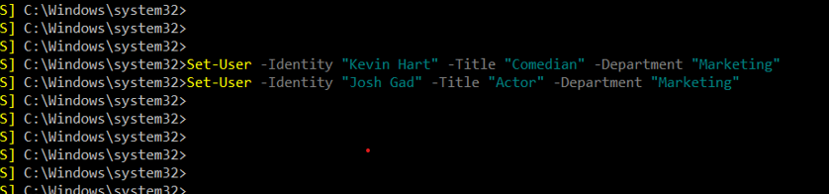

Create a new accept domain  
<condorid>-info2260.com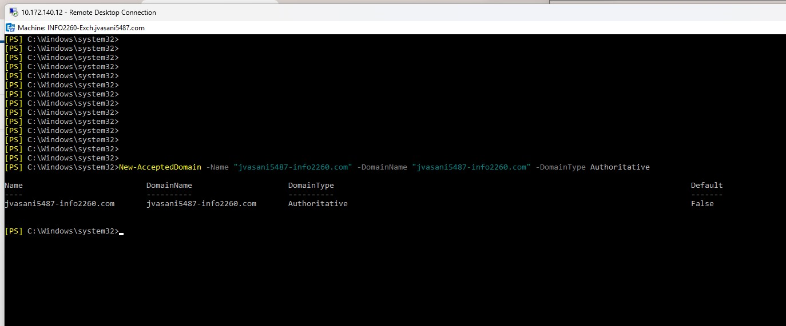

Create a new distribution group. Name: Marketing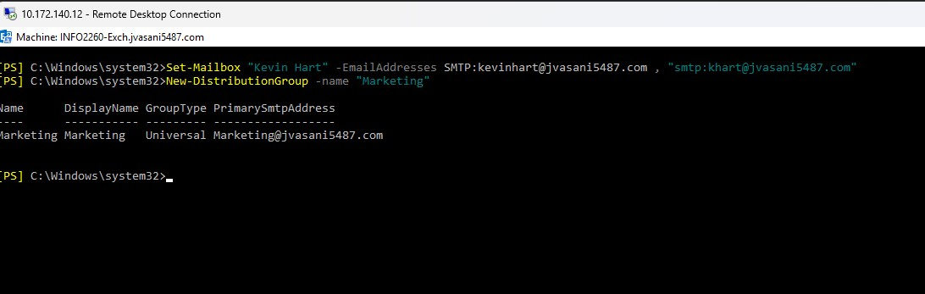

Add all of the members of the Marketing Department to the Marketing distribution group.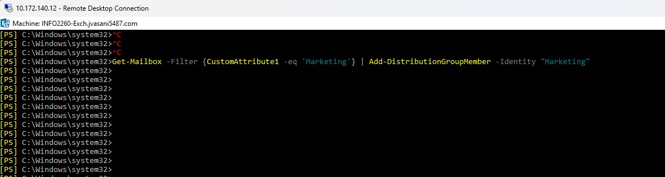

PART B

Using a filter method, get a list of Mailboxes that are in the Users OU 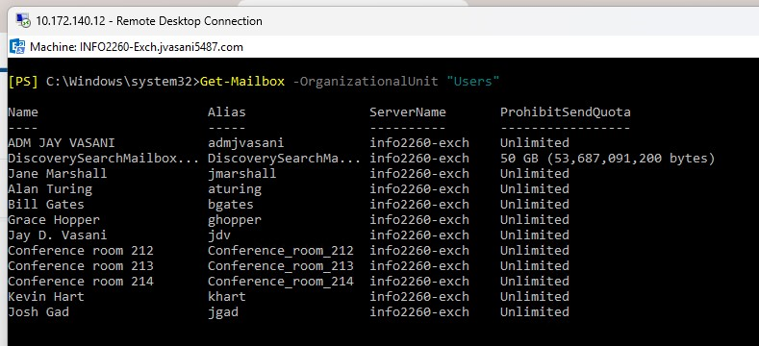

List the Name, and all Email Addresses all users in the Marketing Department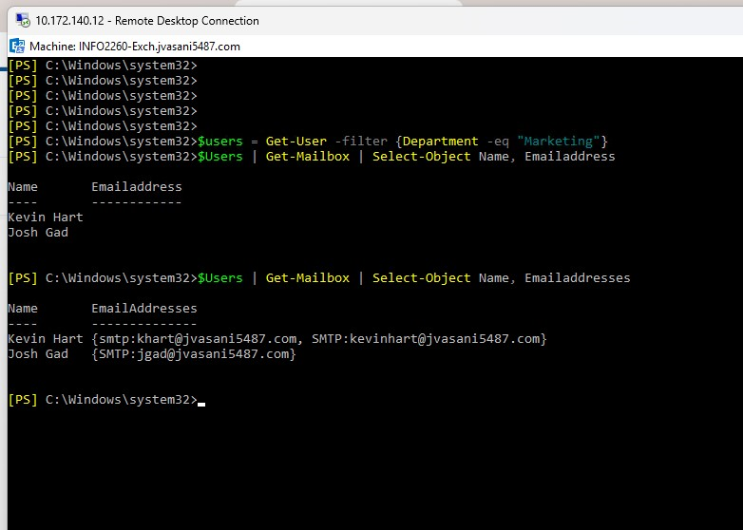

LAB 2.5

PART A

Send an email from Jane Marshall to Grace Hopper and Alan Turing  
a. In the Subject include the phrase: Spring Bonus

All emails sent from Jane Marshall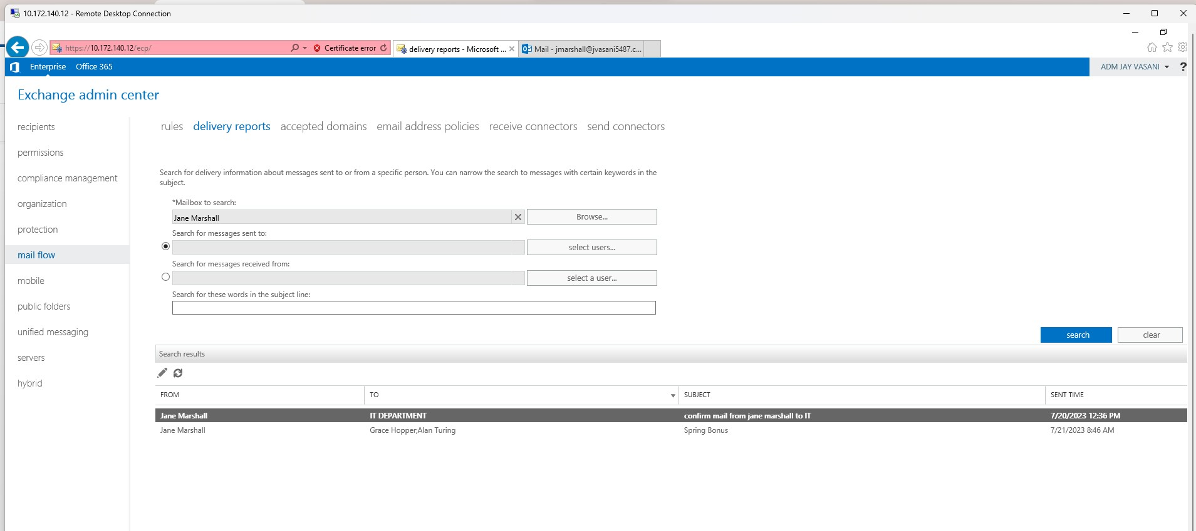

All emails sent from Jane Marshall to Grace Hopper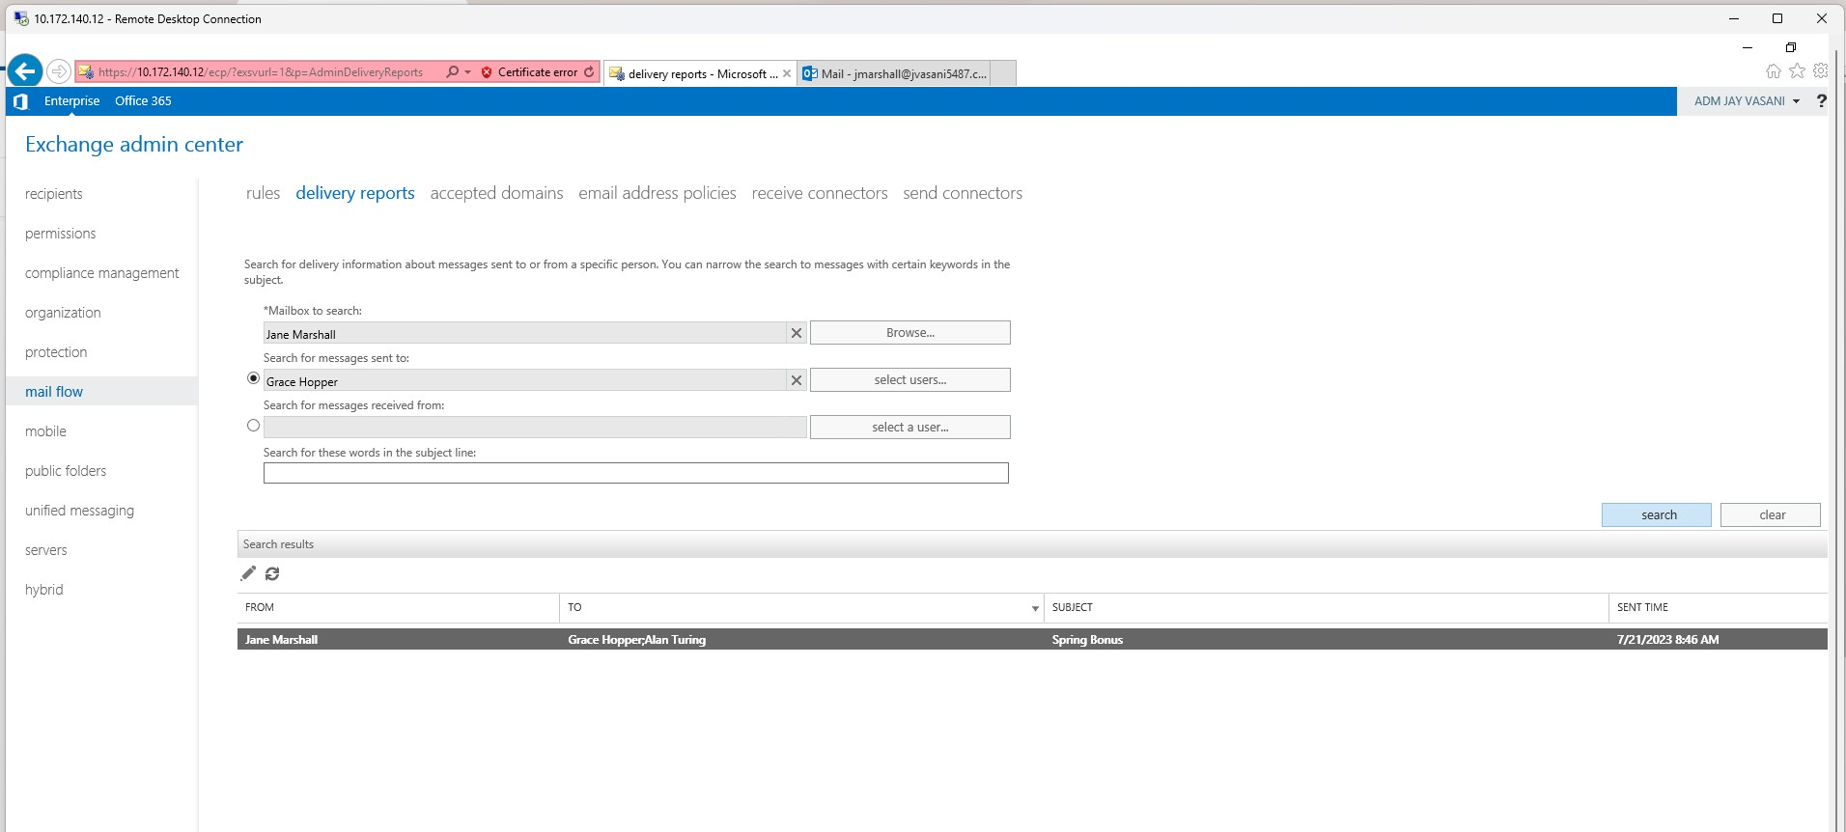

All emails sent from Jane Marshall with the word Bonus in the subject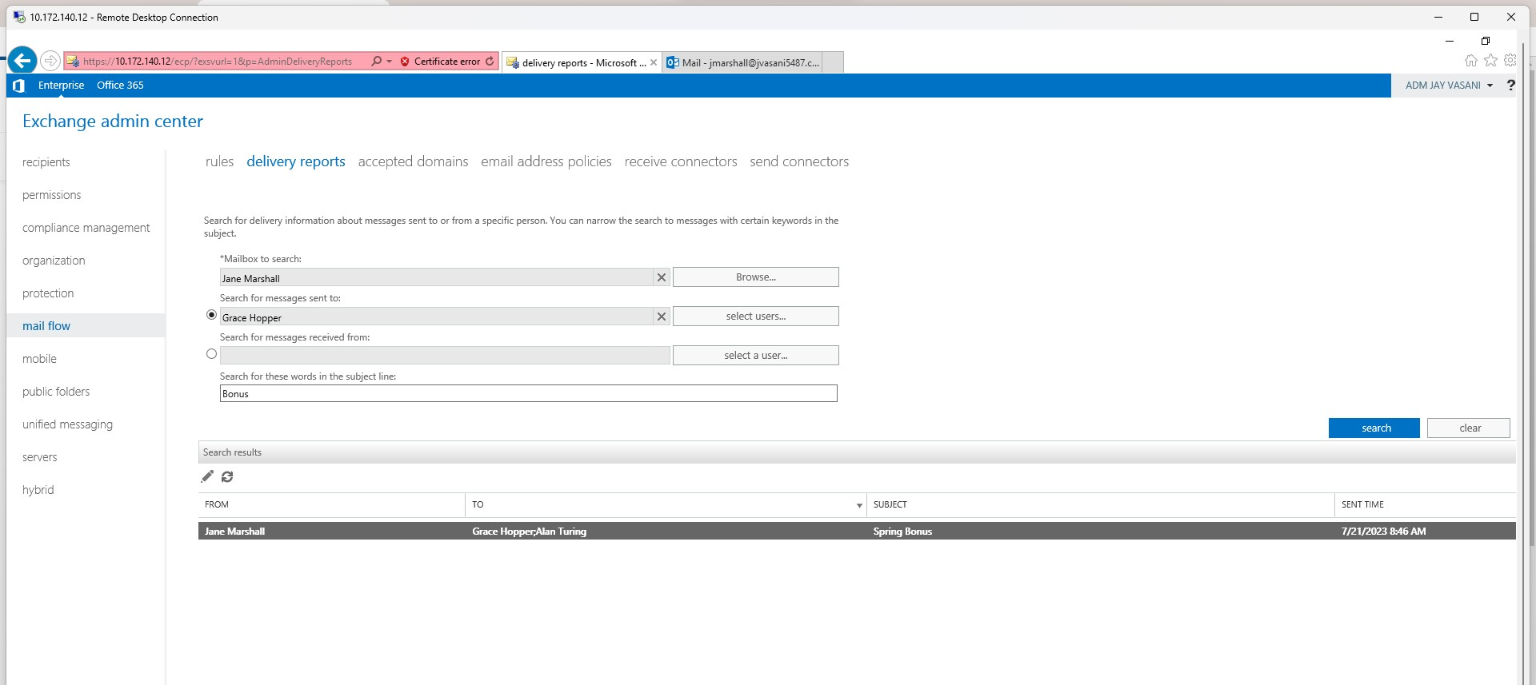

All emails sent to Alan Turing from Jane Marshall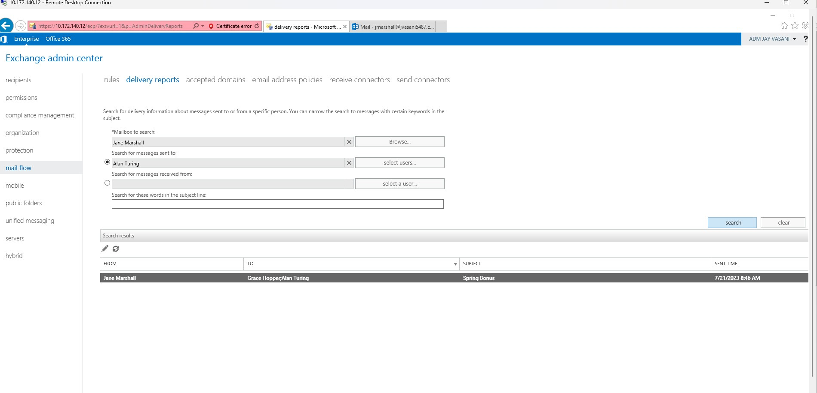

LAB 2.6

PART A

Create 2 new users  
a. Kyle Lowry  
b. Fred Vanvleet

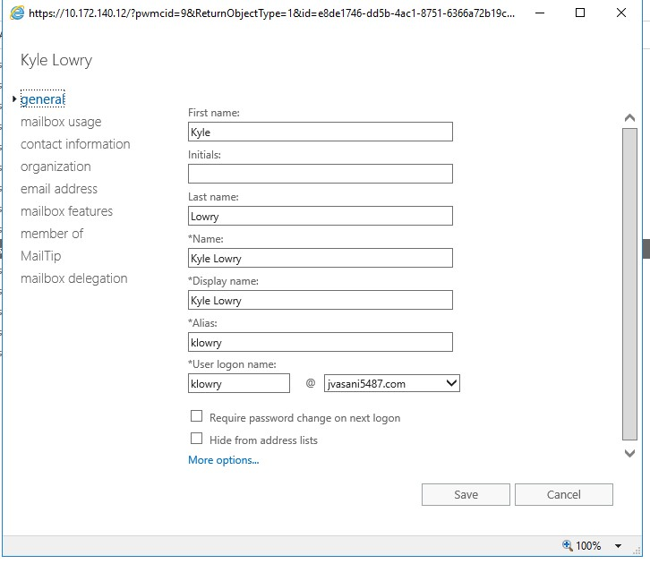

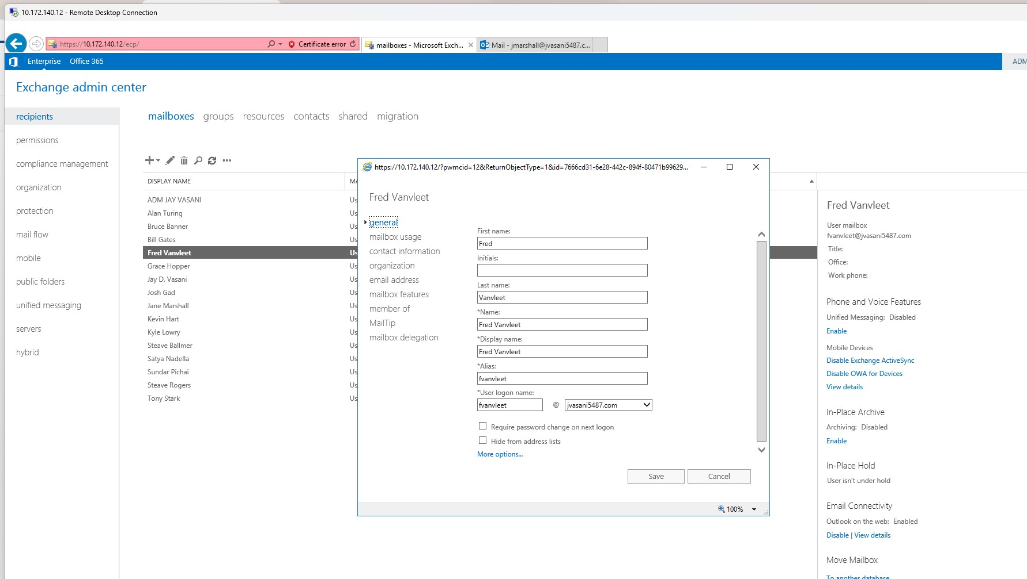

In the Exchange console add Kyle Lowry so that he has the ability to only create modify or  
delete mailboxes and recipients. He should not be able to perform any other actions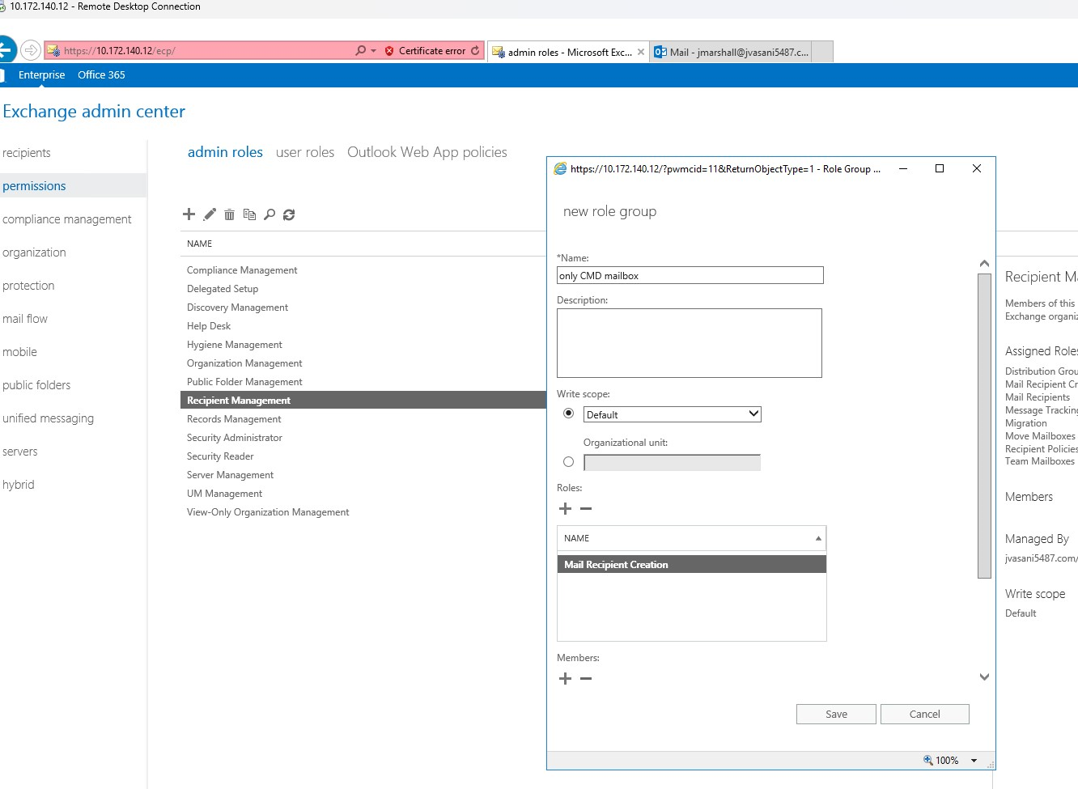

n Active Directory add Fred Vanvleet so that he has ability to read all configuration and  
recipient information but cannot modify anything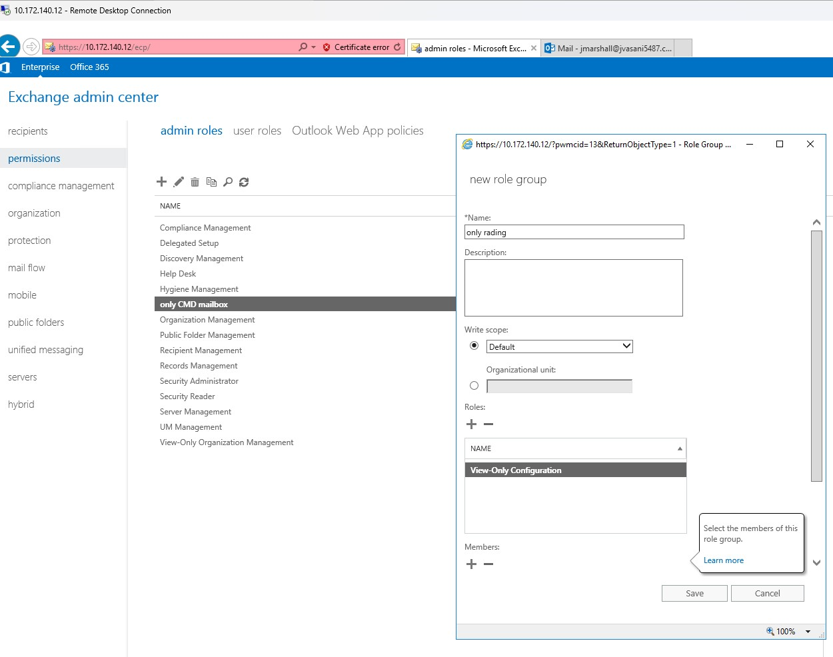

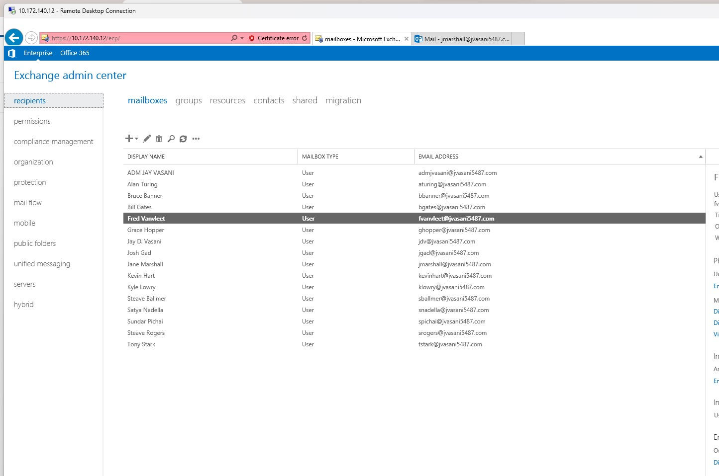

screenshot for proving that the users  
have been applied to the correct administrator role.

